**1.Patient Table:**



**Output:**

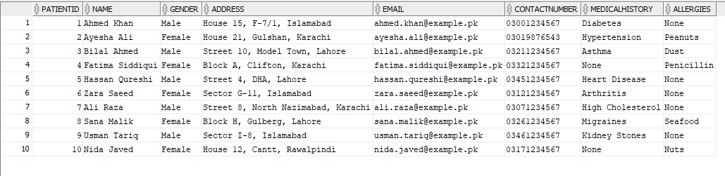

**2.Doctor Table:**



**Output:**

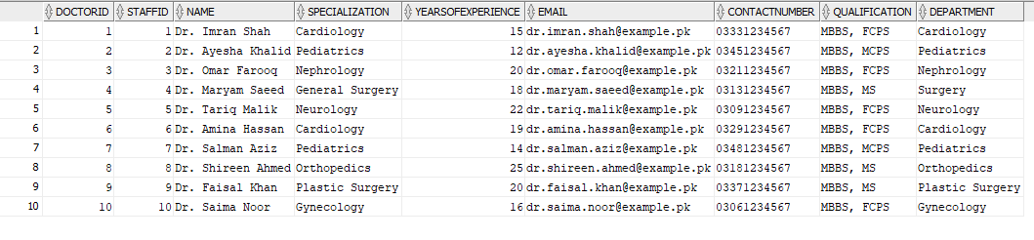

**3.Staff Table:**



**Output:**

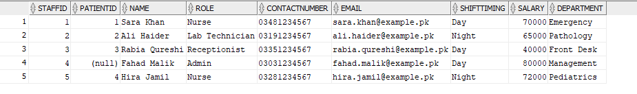

**4.Appointment Table:**



**Output:**

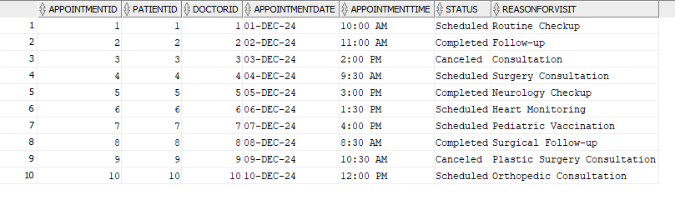

**5.Medical Record Table:**



**Output:**

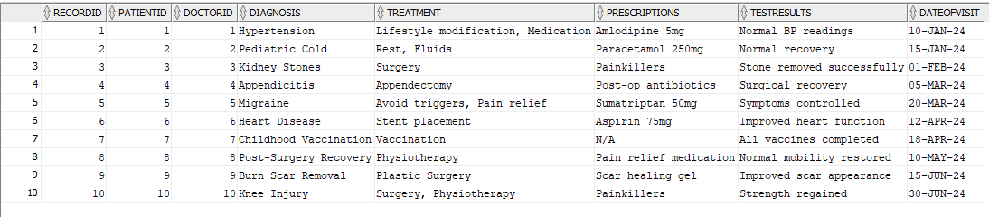

**6.Billing Table:**



**Output:**

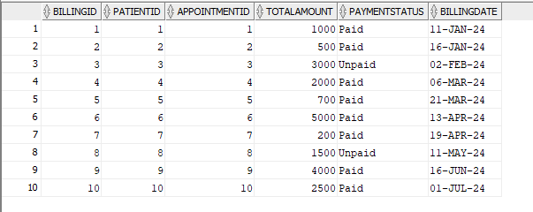

**7.Pharmacy Table:**



**Output:**

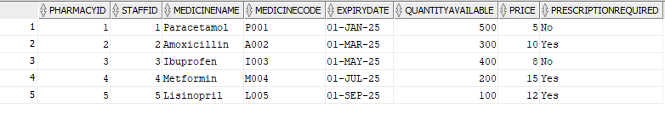

**QUERIES:**

**SELECTING ALL COLUMNS:**



**ARITHMETIC OPERATOR QUERY:**



**CONCATENATED QUERY:**



**ALTERNATE QOUTE (Q) OPERATOR:**



**DISTINCT QUERY:**



**DESCRIBE QUERY:**



**DISPLAYING DATA:**



**WHERE QUERY:**



**BETWEEN QUERY:**



**LIKE QUERY:**



**ORDERED BY AND IN QUERY(DESC):**

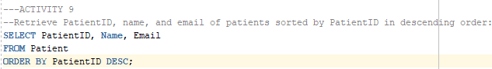

**SINGLE-AMPERSAND SUBSTITUTION VARIABLE:**



**INITCAP QUERY:**



**MOD QUERY:**



**TRUNC AND ROUND QUERY:**



**CONTAIN QUERY:**

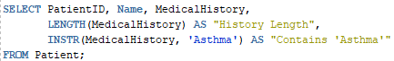

**MONTH BETWEEEN QUERY:**

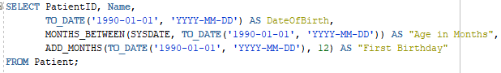

**NVL QUERY:**



**NVL 2 QUERY:**



**COUNT QUERY:**



**COUNT DISTINCT MEDICALHISTORY QUERY:**



**AVERAGE QUERY:**



**GROUP BY QUERY:**



**GROUP BY ADDRESS AND GENDER:**

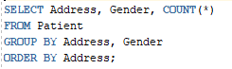

**HAVING QUERY:**

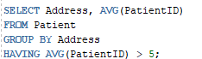

**LIKE USING GROUP BY:**

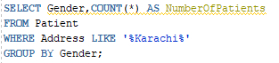

**JOINS:**

**NATURAL JOIN QUERY:**



**OUTPUT:**

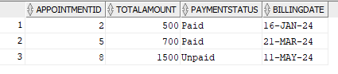

**USING CLAUSE:**



**OUTPUT:**

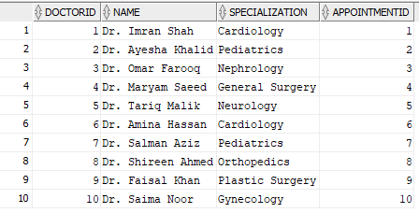

**ON QUERY:**

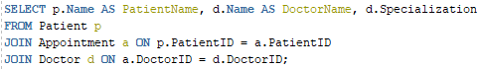

**OUTPUT:**

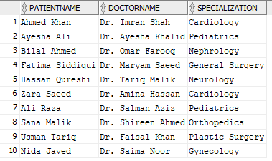

**THREE WAY JOINS:**

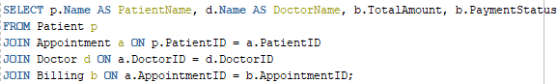

**OUTPUT:**

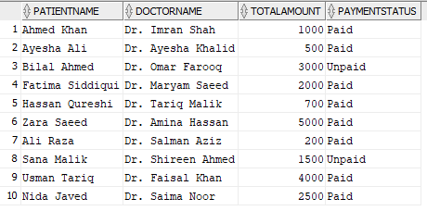

**ADDITIONAL CONDITION TO A JOIN QUERY:**

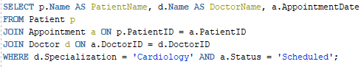

**OUTPUT:**

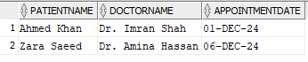

**SELF-JOIN QUERY:**



**OUTPUT:**



**NON-EQUIJOIN QUERY:**

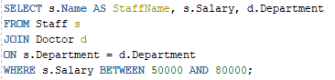

**OUTPUT:**

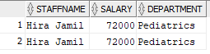

**LEFT-OUTER JOIN:**



**OUTPUT:**

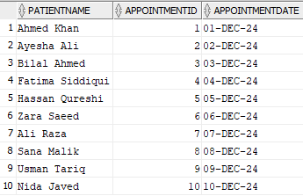

**RIGHT-OUTER JOIN:**



**OUTPUT:**

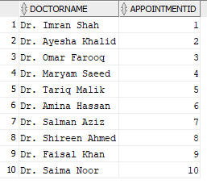

**FULL OUTER JOIN:**



**OUTPUT:**

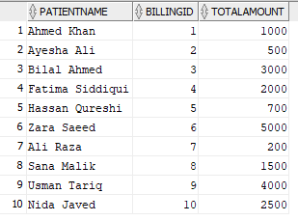

**CROSS JOINS:**



**OUTPUT:**

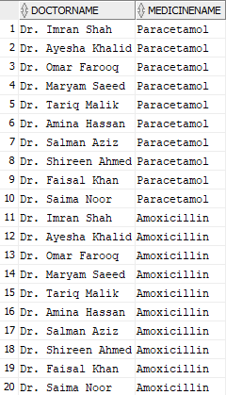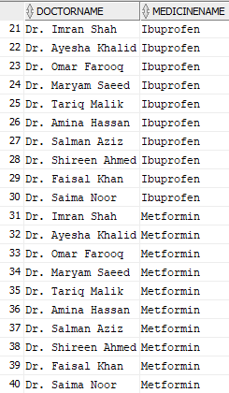

**QUERY INSIDE QUERY:**



**SUB QUERY GROUP BY AND HAVING:**

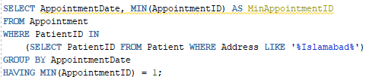

**ANY QUERY:**

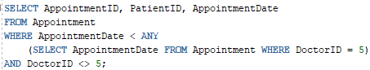

**ALL QUERY:**

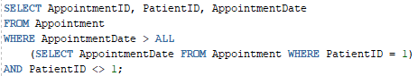

**EXIST QUERY:**

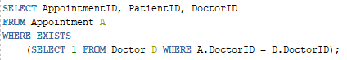

**NULL VALUES IN MULTIPLE SUBQUERIES:**

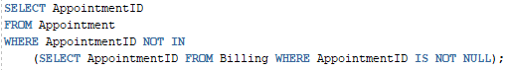

**UNION QUERY:**

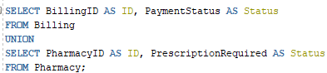

**UNION ALL QUERY:**

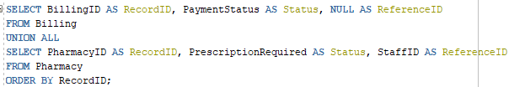

**INTERSECT QUERY:**

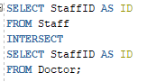

**MINUS QUERY**

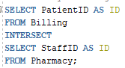

**ORDER BY CLAUSE IN SET OPERATIONS:**

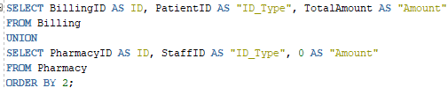

**INSERTING QUERY:**







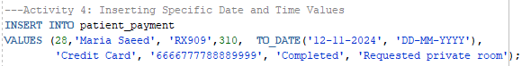

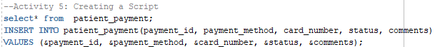

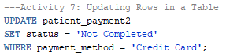

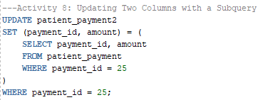





**DOCSSSS1 TABLE:**

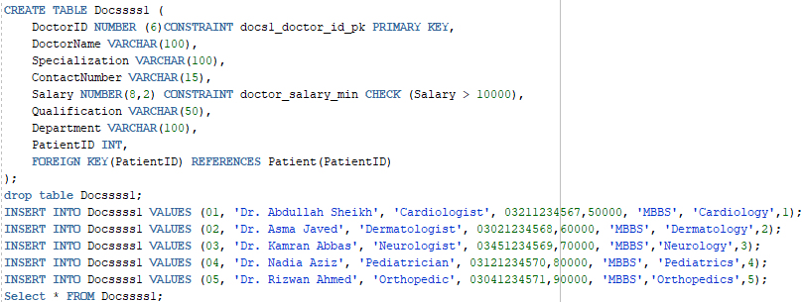

**VIEWS:**

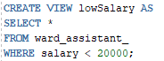



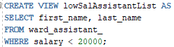

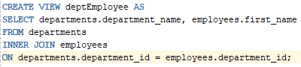

**OUTPUT:**







